2

0

1

3

-

1

4



**ANNUAL ACTIVITY REPORT**

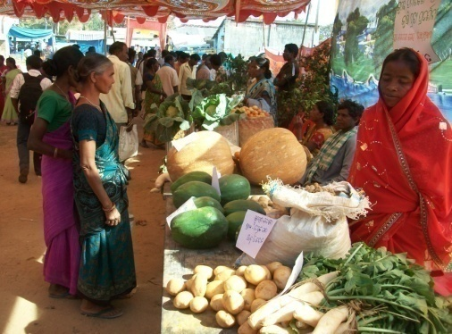

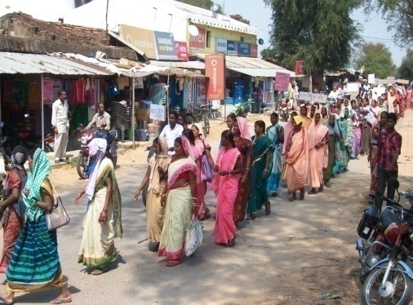

SAMAJIK SEVA SADAN

Banjhikusum, Mahisapat,

Dhenkanal -759013, Odisha, India

Telephone- 06762-286628,

Email:sssorgdkl@gmail.com

Url : www.sssdklindia.org.

**From the Director**

We have the privilege of bringing out the Annual Activities Report of Samajik Seva Sadan. The Report broadly covers different activities, events, projects and programmes initiated and implemented by SSS during the year 2013-14. The Annual Report provides a glimpse of the processes to achieve this objective.

Administering developing programmes, especially among a population with developmental indicators being in the bottom part of list in national context; it is imperative that advantage of technology is adopted in all implementation, planning, monitoring and evaluations. It makes the work more effective.

We, the Samajik Seva Sadan family acknowledge with sincere thanks the contribution of all our patrons, all institutions and individuals those have contributed substantially or slightly to the cause for which the institution was established. Without their support, it could not have been possible complete the decades plus journey.

I sincerely hope to continue to receive it further times to come.

Emmanuel Pathil

*Director*

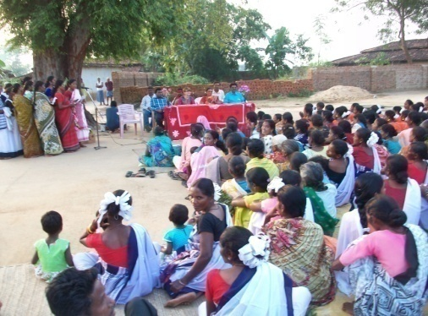

**An Overview**

Samajik Seva Sadan began itself with a non-formal education center at Banjhikusum a **JUANG** Indigenous hamlet, in 1982. From 1983, marked by establishment of rapport with the communities and better understanding of the magnitude of the problems, issues affecting the communities, it extended its service to 15 more hamlets around Banjhikusum to alleviate poverty by 1985. The Organization got itself Registered in 1985 Under the Societies Registration Act of 1860 to become a legal entity. In 1986 it was registered Under FCRA & in 1987 Registered with Income Tex Department and under 80G in 2007. Samajik Seva Sadan is accredited by Credibility Alliance, New Delhi in the year 2011.

Samajik Seva Sadan is outcome of an effort to address social issues, a need to empower the vulnerable part of the community; especially women and children, poverty stricken population living in remote, tribal areas, forest dwellers, artisans etc. Established in 2004, Samajik Seva Sadan within this span of its interventions has implemented programmes to enhance the quality of lives of such persons, strengthening their respective financial capacity, emerging as a collective in different formats, SHCs, and be able to create assets to address their needs at own level.

In pursuance of its objectives, Samajik Seva Sadan has implemented projects and programmes pertaining to women and child development, education for the children, addressed youth and adolescent issues, nutrition issues, women empowerment and protection, Health & sanitation, address livelihoods issues, financial inclusion and literacy etc.

MISSION STATEMENT : To Mobilize support service & Implement pro-people programs for structural poverty alleviation with a direct Poverty Alleviation Input, Social Reconstruction, Policy Advocacy, Empowerment of Women & Gender Equity, Total Health, Capacity Building of Youth, Skill Development of Children & Infrastructure creation for and by the people.

**Geographical Area of Operation**

At present Samajik Seva Sadan is working in the entire Dhenkanal District of Odisha State. However, most of the activities are concentrated in Sadar and Parjang Block of Dhenkanal. In Angul District our work began with the internationally acclaimed Environment Protection & Pressurizing the Industries and Mining Houses to take minimum pollution control measures lasted for 4 years and the result was much more than the expected out come. We also worked in Sadar, Banarpal and Chhendipada Blocks of Angul District on total sanitation & safe drinking water supply. Similarly the organization is undertaking development works in Subdega Block of Sundargarh District from 1998 and has extended to Balishankra, Bargaon and Sadar Blocks of Sundargarh. More than 15,00,000 people have benefited from the activities of the organization directly or indirectly.

The Head Office of Samajik Seva Sadan is located at Banjhikusum, Mahisapat in Central region of Dhenkanal and its Project Office at Subdega, Sundargarh district of Odisha. Tribal and forest covered area in Northwest region of Odisha bordering with Chhattisgarh and Jharkhand.

**Operational Area**

|  |  |
| --- | --- |
| District | Area |
| Dhenkanal | Sadar Block  Parjang Block |
| Angul | Sadar Block  Banarpal Block  Chhendipada Block |
| Sundargarh | Sadar Block  Subdega Block  Balishankra Block  Bargaon Block |

**Organization Structure**

**Governing Body**

**General Body**

**President**

**Director**

**Secretary**

**Administration**

**Programme**

**Accounts**

**Secretarial**

**Support Staff**

**Governing Body**

**General Body**

**President**

**Director**

**Secretary**

**Administration**

**Programme**

**Accounts**

**Secretarial**

**Support Staff**

**Target Group :**

☞ Adivasies, Dalits & Rural poor ☞ Elected PRI Representatives.

☞ Women & Destitute ☞ Small and Marginal farmers

☞ Children Dropouts & Child Labors ☞ Minority Communities

☞ Physically Challenged & Orphan Children ☞ Rural Artisans

☞ Youth / Adolescent girls & boys ☞ Leprosy, HIV/AIDS patients

**Priority Area of Operation**

* Quality Primary & Secondary Education and prevent Child Labour.
* Personality & Leadership dev. & Vocational Training for Youth and Adolescent Girls.
* Human Rights Promotion by Awareness Generation & Advocacy.
* Training and Capacity Building of PRI & Potential women Leaders.
* Strengthening Palli & Gram Sabha for Good Governance.
* Educating people on Govt. programs and access it.
* Reproductive Health of women, Child Development & Environment.
* Women empowerment.
* Prevention of Trafficking by counseling and awareness building in villages.
* Campaign on HIV / AIDS & STD.
* Mitigate Climate Change and Solar LED Lantern Promotion.
* Environment, Plantation and Regeneration of Degraded Forest.
* Agriculture, Horticulture, Bio-farming and Water Conservation.
* Natural Resource Management, Food Security & Livelihood.
* SHG formation & Promotion of Self Help Cooperatives.
* Income Generation program, individual and collective.
* Promotion of Tribal Culture and Development.
* Relief & Rehabilitation.

**ACTIVITIES**

**Activities for the year 2013–14**

In the current year Samajik Seva Sadan undertook the following projects / programs for the realization of its goal of **making the people masters of their own destiny.**

|  |  |  |  |
| --- | --- | --- | --- |
| **Sl. No.** | **Name of the Program** | **Area of Implementation** | **Source of Funds (Donor Agency)** |
| **Village, G.P. Block & District** |
| 1. | Socio-Economic & Political Empowerment of Tribal & Dalit Women through Self-Help Cooperative (SHC) Society. | 68 villages of Subdega Block in Sundargarh, Odisha. | Andheri-Hilfe, Bonn e.V, Germany. |
| 2. | Hostel for SC & ST Girl Students of Anchalik Sahayog +2 College, Subdega, Sundargarh. | Subdega Block, Sundargarh District, Odisha. | S.S.S. Self Supported with contribution from Hostellers. |
| 3. | Gangpur Industrial Training Centre (GITC) | Subdega Block of Sundargarh District | Self Supported with contribution from the trainees as well as supported by the Ministry of Tribal Development. |
| 4 | Hostel for GITC Boys and Girls in separate locations at Kainsra for boys & for girls attached to existing Girls Hostel, Subdega. | Subdega Block, Sundargarh District, Odisha. | Ministry of Tribal Affaires through Directorate of Employment and ITDA |
| 5 | Tribal & Dalit Women Empowerment in Dhenkanal | 48 villages in Sadar Block of Dhenkanal District, Odisha. | S.S.S Self supported. |
| 6 | Plantation in the campus of Rungta Mines. | Within own plant area of Rungta Mines Ltd. (Tarkabeda area to Jharbandha area). | Rungta Mines Ltd., Dhenkanal Steel Plant, Korian, Dhenkanal. |
| 7 | Sustainable Livelihood of Adivasis and Dalits in 4 G.Ps of Subdega Block through Agriculture and Allied Activities | 68 villages of Subdega Block in Sundargarh, Odisha. | Andheri-Hilfe, Bonn e.V, Germany with Local Contribution from the people. |
| 8. | Organizing and strengthening the Dalits community to enhance their socio-economic and educational status for living a dignified life. | 10 villages of 2 GPs in Sadar Block of Sundargarh District. | Centre for World Solidarity (CWS), Bhubaneswar. |
| 9 | Strengthening the participation of indigenous peoples particularly the role and contribution of indigenous women in sustainable resource management - | 3 villages of Subdega Block of Sundargarh District. | Asia Indigenous Peoples Pact (AIPP), Thailand. |
| 10 | WSHG to empower the economical statues of women | In 7 GPs of Prajang Block in Dhenkanal District. | Entrepreneurs Development Institute of India (EDII) with NABARD support. |

1. **Socio-Economic & Political Empowerment of Tribal & Dalit Women through Self-Help Cooperative Society in Sundargarh:**

The SHCs play an important role in uplifting their lives through various production and consumption activities.

Self Help Cooperatives (SHCs) are functioning exclusively for socio-economic and political women empowerment in four GPs of Subdega Block of Sundargarh. In order to make all the target villages of 4 G.Ps sustainable in their development Samajik Seva Sadan is trying to include all the families in their respective SHCs. The Khut kati Sathi (KKS) means Animators in Adivasi Language-‘Sadri’ are interacting with each family every month. It becomes easy for them to convince the excluded families to become members of SHCs because all the programs under this project, the beneficiaries will be the member families of SHCs. In this year 246 families have joined SHC.

The Govt. of Odisha that promulgated the Self Help Cooperative Act, withdrew it in 2013, so all our cooperatives had to reregister under the 1962 Cooperative Act and it is done. The present Status of the 4 Women SHC is as follows:

|  |  |  |  |
| --- | --- | --- | --- |
| Name of SHCs | GP | Total member | Total saving Amount |
| Nari Shakti MPSS Ltd. | Kurumkel | 402 | Rs. 35,60,000/- |
| Nari Pragati PSS Ltd. | Subdega | 490 | Rs. 48,09,000/- |
| Nari Kalyana PSS Ltd. | Damkuda | 340 | Rs. 39,01,000/- |
| Nari Jagarana PSS Ltd. | Jamuna | 335 | Rs. 26,06,000/- |
| Total | 4 SHCs | 1567 | Rs. 148,76,000/- |

1. **Hostel for SC & ST Girl Students of Anchalik Sahayog +2 College, Subdega, Sundargarh**.

In 2013 – 2014 there were 20 girl students residing in the Girls Hostel. Out of these, 5 girls were +2, 2st year, studying in ***Anchalik Sahayog College.*** **SSS** supports the running of the Hostel by all its revenue as well as food expenses contributed by the parents of the hostellers. ***,*** and 15 of GITC, Subdega supported by Govt. through LWE scheme and Central Grant in aid through ITDA.

1. **Gangpur Industrial Training Centre (GITC).**

We received the **Affiliation Reference of NCVT/DGE&T** - 6/18/70/2010-TC (New - Pvt.), Date - 30/07/2010 from New Delhi. This year we have 32 students admitted to the 2 years training course in fitter and Electrician Trades. Together with the previous year’s 36 student, in total we have 62 students in GITC

1. **Hostel for GITC Boys and Girls in separate locations at Kainsra for boys & for girls attached to existing Girls Hostel, Subdega.**

32 ITI Students of GITC is staying in our both boys and Girls Hostel. 15 girls in Girls hostel and 17 Boys are staying in Boys Hostel at Kainsra. Under the scheme the boys and girls total expenditure will be reimbursed. But when is the question ?.

1. **Tribal & Dalit Women Empowerment in Dhenkanal.**

Three cooperatives are running well, members are taking loan for business purpose (Production loan) and they are repaying the amount as per schedule. In the year 2013-14 Nari Pragati Prathmik Mahila Samabaya Ltd, Bhapur have 328, Samaja Kalyana Prathmik Mahila Samabaya Ltd, Talbarkot have 249 and in Nari Chetana Prathmik Mahila Samabaya Ltd, Saptasajya have 242 members, all total 819 members in 3 Self Help Cooperatives (SHCs). The Self Help Cooperative Society registered in Dhenkanal too had to get it registered under 1962 Act after the withdrawals of SHC Act of 2001 by the Govt. of India.

1. **Plantation in the campus of Rungta Mines.**

Samajik Seva Sadan involved in planting trees because it is necessary to plant trees to sustain human life, environment and protect biodiversity. But in our part of the world we care little about planting and preserving trees to sustain our lives and those of wild life etc. Samajik Seva Sadan have planted 2500 saplings at Steel Plant site of Rungta Mines. We have an 85% success at the end of our project on 3rd August 2014. The Company is yet to relies the last payments.

1. **Sustainable Livelihood of Adivasies and Dalits in 4 G.Ps of Subdega Block through Agriculture and Allied Activities**

Altogether 45 villages, people were ready to sacrifice individual selfishness and take up community approach for integrated development of their village. Two years are over and the 3rd year has begun. The plans prepared by the people are being executed by the people themselves with our monitoring and active guidance. The Target people have understood the importance of this project and own it for their Sustainable Development.

1. **Organizing and strengthening the Dalits community to enhance their socio-economic and educational status for living a dignified life.**

A pet project of CWS executed through SSS. The small amount given by the Donor Agency ASW to CWS is transferred and it reaches the organization in small amounts almost like reimbursing the expenses. Though small, it served a lot to the Dalits to get them recognized by the District Administration and was appreciated by the Dalit Community of 2 GPs of Sadar Block in Sundargarh.

1. **Strengthening the participation of indigenous peoples particularly the role and contribution of indigenous women in sustainable resource management**.

It is the first time SSS is getting support from Asia Indigenous Peoples Pact (AIPP), Thailand Our commitment in working for the Indigenous Peoples attracted AIPP towards us and it is an Honor for us. We are proud of AIPP, Thailand for recognizing the Dedication and Commitment we have for our Target people. In this project we are working for 3 Adivasi villages viz. Dungijharia, Mahulmunda and Kattanpada of Subdega Block in Sundargarh..

The Objectives with which we have involved are to raise the capacity of Indigenous peoples,(Adivasies/Tribal) including both women and men are strengthened to articulate and assert their rights. Promote the Indigenous Knowledge relating to sustainable natural resource management, climate change, food sovereignty and livelihood. That they have secured their rights to land territories and resources, including forests in course of time. That they have sustained their engagements in relevant mechanisms, processes and bodies relating to biodiversity for sustainable development in course of time.

We conducted Baseline Survey in each village with the reference of format sent to us by AIPP. The next activity was to involve the people for Social mapping and Resource mapping. These two activities people in large numbers turned out and actively participated. They volunteered to mark various resources the village possesses in common and also individual.

At the end of the exercises, they ware surprised to a great bit especially the vast forest area near their village belongs to them. This made them to apply for the entitlement of their share of forest in the name of their village to Forest Right Committee (FRC). It was passed by the FRC and recommended it to Sub Division Level Committee (SDLC) and passed it and forwarded it to the District. The District is yet to recommend it to the State.

1. **WSHG to empower the economical statues of women.**

Samajik Seva Sadan was contacted by Enterprise Development Institute of India (EDII) through NABARD to promote 50 Women Self Help Groups in Parjang Block of Dhenkanal District on 01 / 08 / 2012. We accepted it and started working intensively. By December we formed 20 WSHGs and by May 2013, all the 50 groups ware formed and they started regularly depositing Rs. 50/- as their monthly contribution. From October 2013 the groups decided to save Rs. 100/- per month.

We are proud to tell that by January 2**0**14, all the 50 groups were linked with Bank and Have received Loan for Income Generating Activity (IGA) to the tune of Rs. 30,000/- to Rs. 1.00,000/- We have 2 committed women workers who are doing a dedicated work in creating awareness among the women and organize them to form such Community Based Organization (CBO) in Parjang Block.

There are 578 women members in the 50 WSHGs, They have a total collection of Rs. 2,00,000/- as their savings and Loan from the Banks add up to 16,00,000/-. We would say that we have achieved the objective of the scheme to protect our women from not to join the Left Wing Extremists (LWE).

**Skill Development Training**

Our experience enables us and we realize that, before fostering any developmental programmes to the people they must be capacitated on the issue and they should have been the conceptual clarity on the aim and objects of the programme meant for them. Keeping in view, we organized the following training programmes.

|  |  |  |  |  |
| --- | --- | --- | --- | --- |
| Training theme | Venue | Duration | No of trainees | Achievement |
| 1. Sensitization on Gender Equality.  2. Result based Monitoring Tools.  3. Preparation of “Moo Aushad” (Bio- fertilizer & bio-spray)  4. Training on ST/SC prevention of atrocities to women and other women related Laws.  5. Training on RTI,RTE, FRA and MGNREGA,  6. Farmers Club members along with other villagers ware trained in Agriculture and Horticulture. | Adikar Training centre, Bhubaneswar  SSS meeting hall  4 villages of Target GPs.  Two villages of 2 GPs in Sadar Block of Sundargarh.  22 villages of project area.  Centrally in 4 villages of 4 GP. | 5 days  2 days  4 days  2 Days each.  1 day each  2 days each | 4 workers  14 workers  200 people  59 w0men and 18 men.  600 men and women participated  400 farmers participated. | Better understanding among the workers. Imparted the knowledge to the co workers and the Target Communities.  Able to monitor the activities to achieve the result. Monitoring tools were shared with the Social Watch Team(SWT) who followed up in the monitoring of activities.  Able to grow poison free vegetables  Women are respected and violence at home is reduced.  People got information through filling RTI, Started Monitoring the schools, Large number of people started applying for Job and received receipt with the application and got Job.  Good number of people started following the crop colander and using the Moo Aushad produced sufficient vegetables for own consumption and sold in the market to make good profit. Farmers Convention and exhibition was the best result. |

**Promotion of Farmers Clubs**

|  |  |  |  |  |  |
| --- | --- | --- | --- | --- | --- |
| Sl. No. | GP | Village | No. of farmers | Assistance from NABARD | Saving status |
| 1 | Kurumkel | Tentulijharia | 60 | Nil | 2500.00 |
| 2 | -do-  -do-  -do-  -do- | Simdega | 45 | 5000 | 7800.00 |
| 3 | Kurumkel | 25 | 5000 | 9000.00 |
| 4 | Hutupani | 40 | Nil | 3000.00 |
| 5 | Kainsara | 35 | 5000 | 6500.00 |

**Distinguished visitors during the year**

* Mr. Raj Kumar Toppo, Regional Officer, Andheri Trust, Bhubaneswar.
* Ms. Devikalyani Pattnaik, Project Officer CWS, Bhubaneswar.
* Mr. Detlef, ASW, Germany
* Mr. France, ASW, Germany
* Mr. Raj Kumar Toppo, Regional Officer, Andheri Trust, Bhubaneswar
* Ms. Janine Langer, India Desk officer, Andheri Hilfe, Germany
* Mr. Ronak Soni, Young Professional (Livelihood).DRDA, Sundargarh.
* Dr. Praful Kumar Majhi, MLA-Talsara Constituency, Govt. of Odisha.
* Dr. Dilip Tirki, MP (Rajya Sabha), Govt. of India.
* Mr. Umakanta Jena, District Labor Officer, Raurkela.
* Mr. Chandrakant Majhi, District Welfare Officer, Sundargarh.
* Mr. K.M. Behera, Principal, Govt. ITI, Raurkela.
* Mr. Harischandra Sabar, District Employment Officer, Rourkela.

**Human Resources**

We are privileged to have a team of experienced, committed and dedicated staff in the service of our Target Communities. They are implementing all the schemes and programs with full dedication and efficiency under the guidance of the Director and the Secretary of SSS Governed by a Governing Body of 8 Members. At present 10 are working on a full time basis and 12 on part-time, 127 numbers of volunteers are associated with the organization. They are available if and when they are called in for their service

|  |  |  |  |  |  |  |
| --- | --- | --- | --- | --- | --- | --- |
| Sl.  No | Name | Sex | Caste | Age | Designation | Full time / Part time & Volunteers |
| 1 | Veronica Dung Dung | F | ST | 50 | Coordinator | Full Time |
| 2 | Gloria Dung Dung | F | ST | 40 | SHC. Supervisor | Full Time |
| 3 | Bibiana Ekka | F | ST | 32 | Project Coordinator | Full Time |
| 4 | Ganeswar Rout | M | GC | 54 | Technical Person | Full Time |
| 5 | Mrutyunjaya Sahoo | M | GC | 37 | Accountant (HQ) | Full Time |
| 6 | Ambuja Phuan | M | GC | 52 | Office Assistant and Liaison Officer (HQ) | Full Time |
| 7 | Emmamalini Soreng | F | ST | 37 | Office Assistant (FO) | Full Time |
| 8 | Blacius Dung Dung | M | ST | 47 | Asst. Accountant(FO) | Full Time |
| 9 | Praful Kullu | M | ST | 39 | Driver | Full Time |
| 10 | Pradip Soreng | M | ST | 39 | Khut Kati Sathi | Part time |
| 11 | Sunil Toppo | M | ST | 37 | -do- | -do- |
| 12 | Pankajini Behera | F | ST | 35 | -do- | -do- |
| 13 | Promila Behera | F | ST | 39 | -do- | -do- |
| 14 | Chandrabati Deheri | F | ST | 30 | -do- | -do- |
| 15 | Manilal Oram | M | ST | 33 | -do- | -do- |
| 16 | James Kullu | M | ST | 43 | -do- | -do- |
| 17 | Albert Lakra | M | ST | 28 | -do- | -do- |
| 18 | Rasmi Lakra | F | ST | 25 | -do- | -do- |
| 19 | Silanand Rabi Tete | M | ST | 45 | -do- | -do- |
| 20 | Dasmi Tanti | F | SC | 30 | Animator | -do- |
| 21 | Suratram Kissan | M | SC | 34 | Coordinator | -do- |
| 22 | Emmanuel Pathil | M | GC | 64 | Director | Full time |

|  |  |  |  |  |  |  |  |  |  |  |  |
| --- | --- | --- | --- | --- | --- | --- | --- | --- | --- | --- | --- |
| Total Number of Staff | | | Professional staff | | | Administrative staff | | | Field staff | | |
| Male | Female | Total | Male | Female | Total | Male | Female | Total | Male | Female | Total |
| 13 | 09 | 22 | 04 | 02 | 06 | 02 | 02 | 04 | 7 | 5 | 12 |

**Membership in Different Forum*:***

To share experiences and build up a concerted effort for development of people, Samajik Seva Sadan has joined hands with other NGOs as well. We are members of different net works and forum.

1. VANI - National Forum for influencing govt. policies on Poor.
2. Educational Consultants - National forum for educational issues.

Consortium

3. GAIA -International Alliance “Global Alliance for Incinerator Alternatives” Philippines.

4. CMAI, New Delhi -Life member of Christian Medical Association of India.

5. Credibility Alliance, Mumbai - National forum

#### Acknowledgement (Partner and Supporting Agencies) :

We acknowledge our sincere thanks to all those who supported us for the last TWENTY-NINE years with funds to assist the villages for their integrated development to become masters of their own destiny, viz:

|  |  |
| --- | --- |
| NATIONAL | INTERNATIONAL |
| Ministry of HRD, Government of India. | MISEREOR, Germany |
| CAPART, New Delhi. | Action Aid, U.K. |
| OEP, Government of Odisha. | NORAD, New Delhi and Norway. |
| OPEPA, Government of Odisha. | SWISS AID, Switzerland. |
| DRDA, Dhenkanal. | COMMUNITY AID ABROAD, Australia. |
| National Horticulture Board, Haryana. | OXFAM INDIA. |
| Gram Vikas, Berhampur, Ganjam, Odisha. | Andheri-Hilfe, Germany. |
| PREM, Berhampur, Ganjam, Odisha | CARITAS INDIA, New Delhi. |
| PRIA, New Delhi. | MIVA, Switzerland. |
| Nehru Yuvak Kendra, Dhenkanal | CASA, Mumbai. |
| National Institute of Naturopathy, Pune. | Centre for World Solidarity (CWS), Germany. |
| Rungta Mines, Odisha | AIPP, Thailand |
| Ministry of SC/ST, Govt. of India. | Ministry of Minority Affairs, Govt. of India.  (National) |

**Legal Compliance**

**Every year Samajik Seva Sadan is reporting to:**

* F.C-3 / F.C - 6 with Audit report to Home Ministry, New Delhi.
* Income Tax returns to ITO, Bangalore.
* Annual report with Audit report and major resolutions to Registrar of Societies, Dhenkanal.
* Consolidated Audited report with utilization certificate along with annual report to all the supporters of Samajik Seva Sadan as well as **to the public who asks for it**.
* This year’s Audit report is herein enclosed. Audit Report can be seen in our Web site.

**List of Board members**

|  |  |  |  |  |  |  |
| --- | --- | --- | --- | --- | --- | --- |
| Sl  No | Name & Address | Qualification | Designation | Sex | Caste | Occupation |
| 1. | Mr. Devendra Kumar Samanta  At / Po – Mahisapat  Dist – Dhenkanal, Odisha  Mobile – 9861767273 | B.A | President | M | GC | Field Manager  SR Company |
| 2. | Ms. Veronica Dung Dung  At.- Banjhikusum,  Po. - Mahisapat, Dhenkanal.  Mobile – 9437864665 | MSW | Secretary | F | ST | Social Activist |
| 3. | Mr. Saranga Padhan  At.- Banjhikusum,  Po. - Mahisapat, Dhenkanal.  Tel. 06762 – 224128 | Metric | Treasurer | M | ST | Master Craftsman (Ferro Cement Technology) |
| 4. | Ms. Puspanjali Rout  At – Mahulkholi  Po – Kapilash, Dhenkanal  Mobile – 9237969822 | B.A | Vice-President | F | OBC | Social Worker  (Staff Representative) |
| 5. | Ms. Sita Murmu  At – Banasahi (Bankual)  Po – Kankadahad  Dhenkanal  Mob - 07537894644 | Under Metric | Member | F | ST | House wife  (People’s Representative) |
| 6. | Mr. Jameswar Prusty  At / Po – Station Road  Dhenkanal  Mobile – 9439411252 | M.A, B.Ed. | Member | M | SEBC | Rtd. High School Teacher |
| 7. | Bilasini Pradhan  Ganjhaidihi Sabar Sahi,  Po – CS Prasad  Dhenkanal  Mob -09583677753 | Metric | Member | F | ST | House wife  (People’s Representative) |
| 8 | Emmanuel Pathil,  At/Po.- Mahisapat,  Dhenkanal.  Mob- 9437079315 | MSW | Director  (Ex. Officio Member) | M | GC | Social Worker. |

**Consolidated Audit Statement**

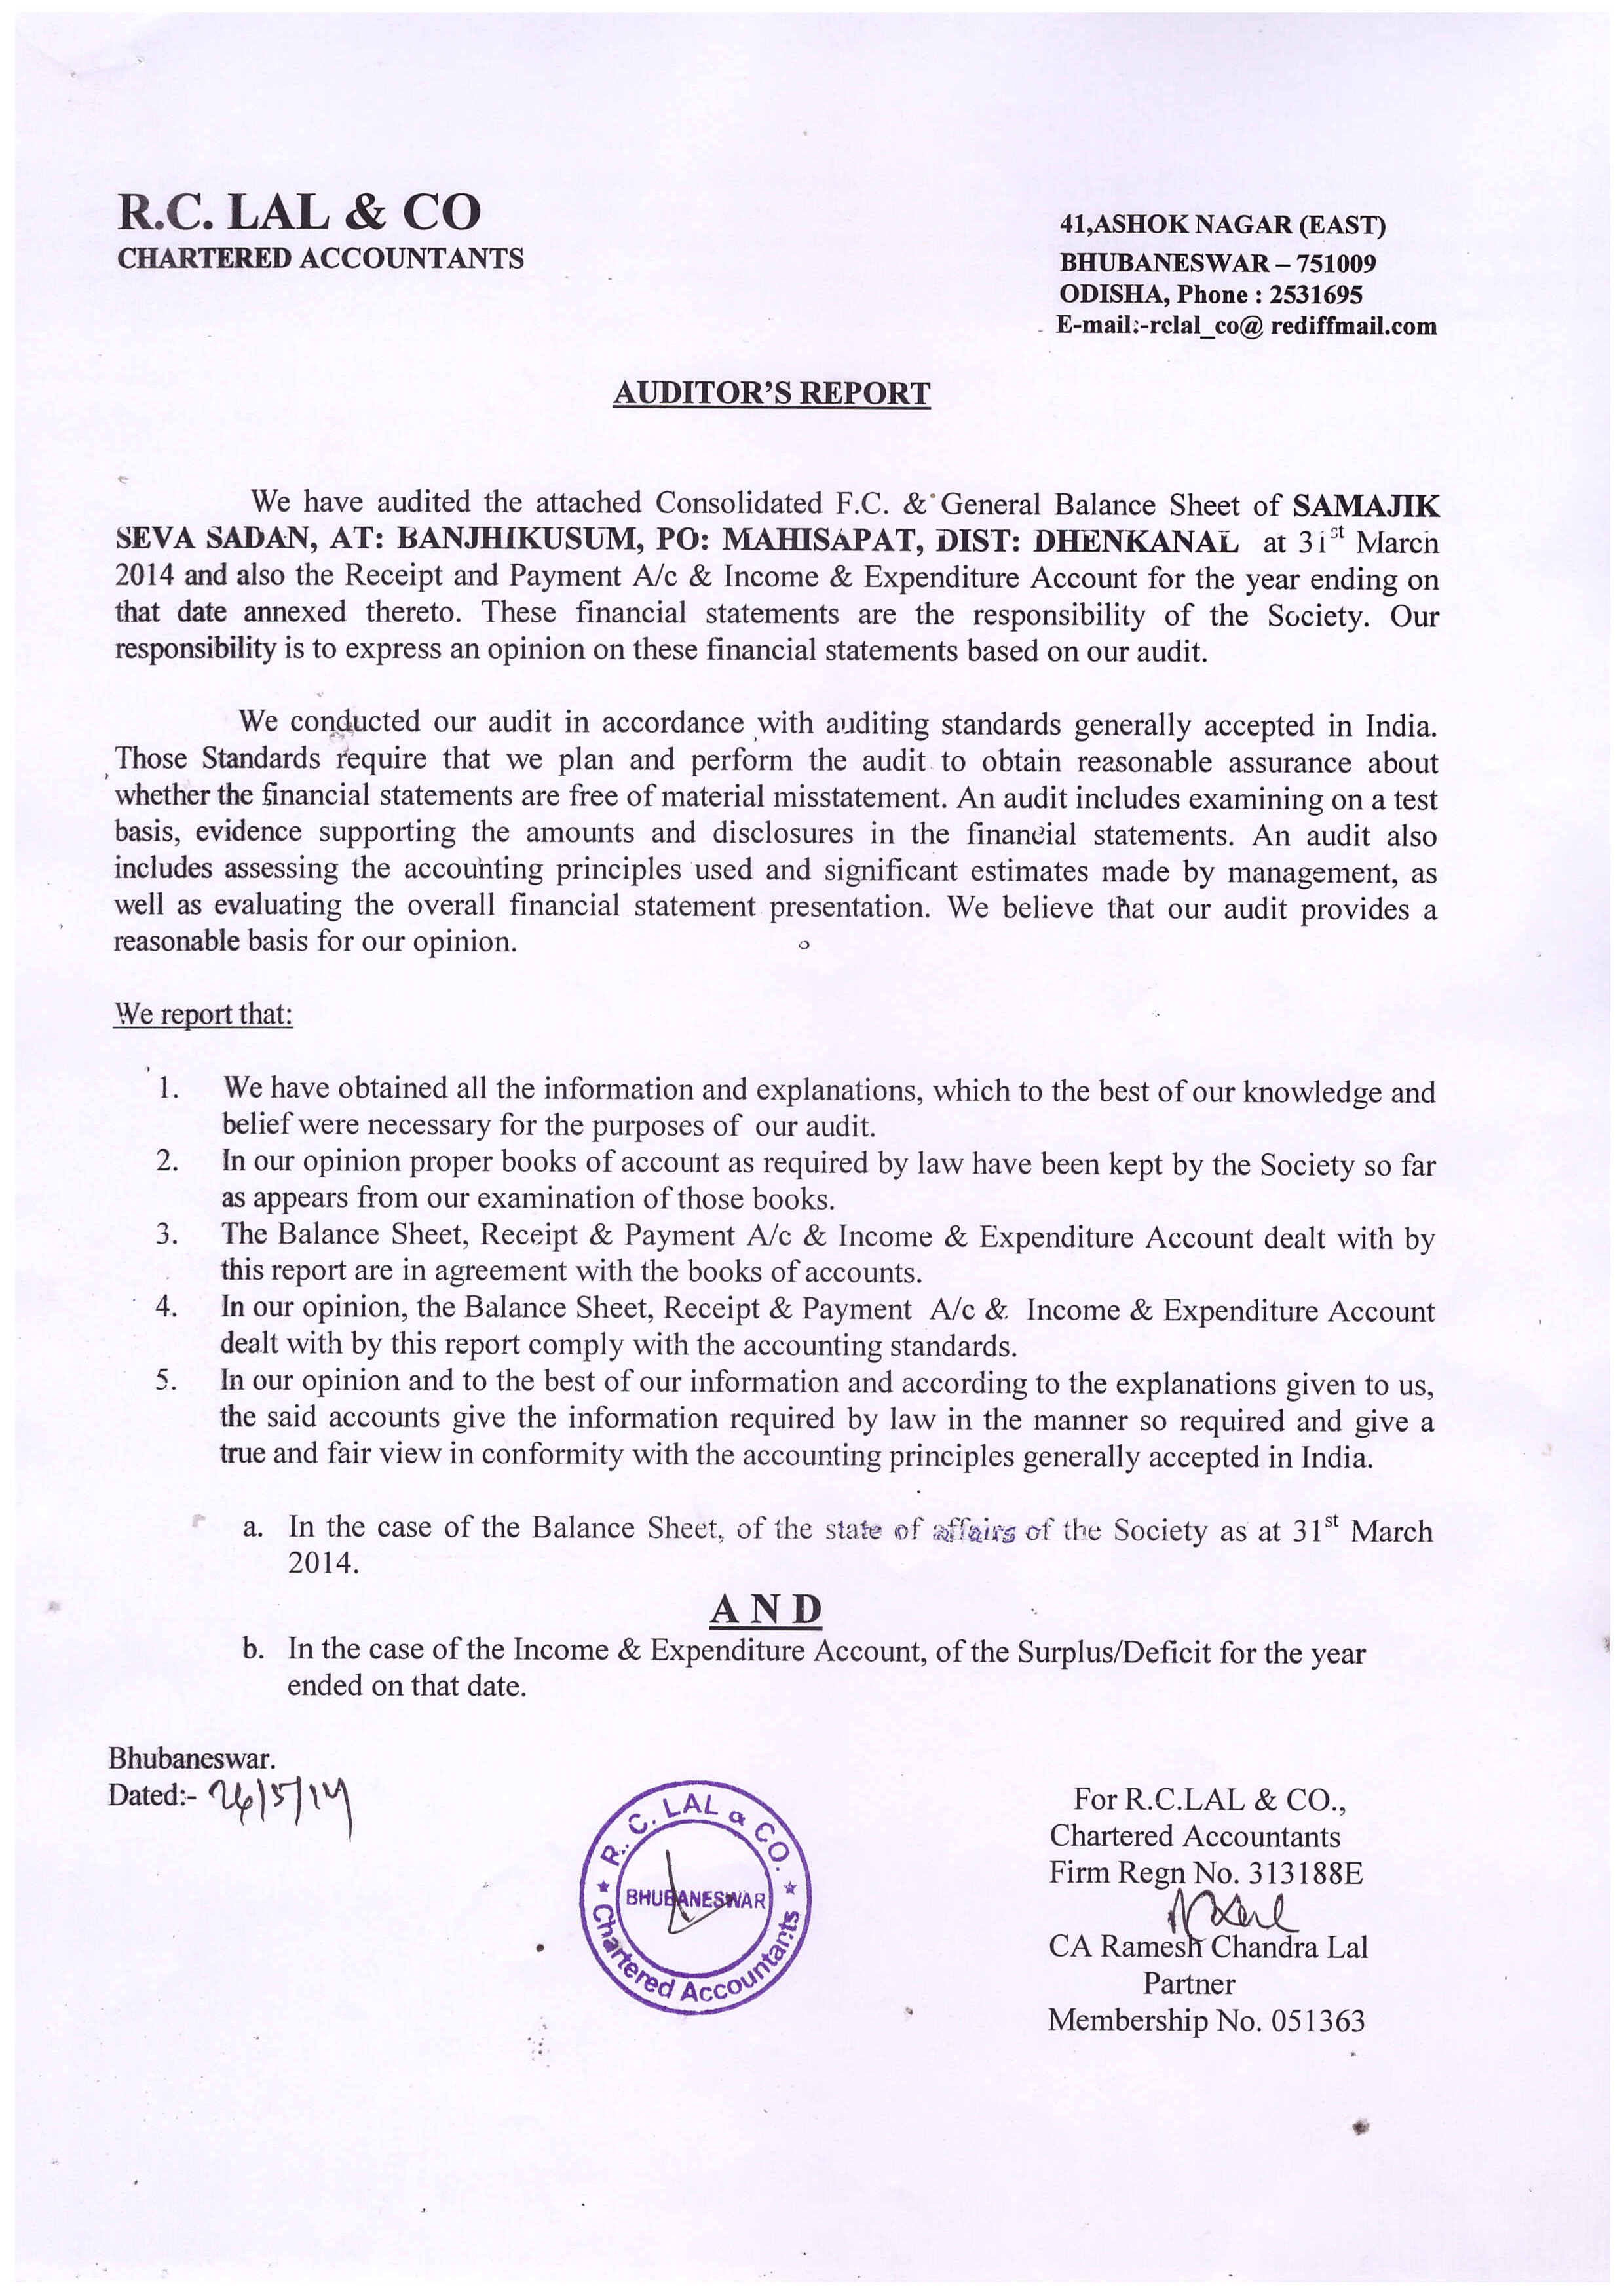

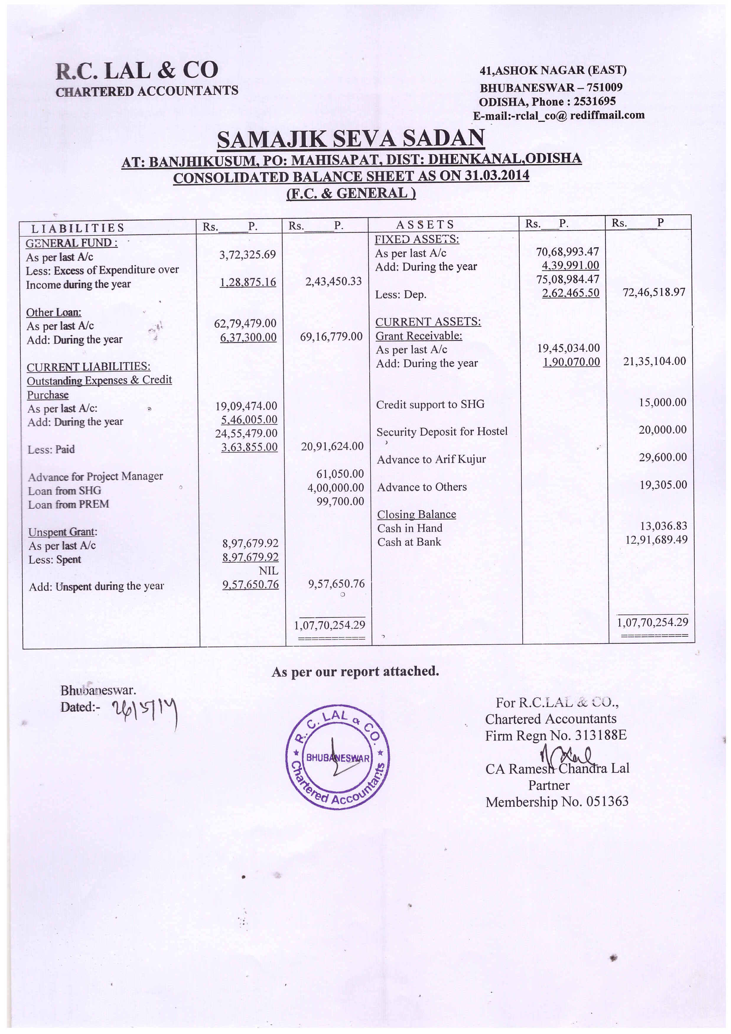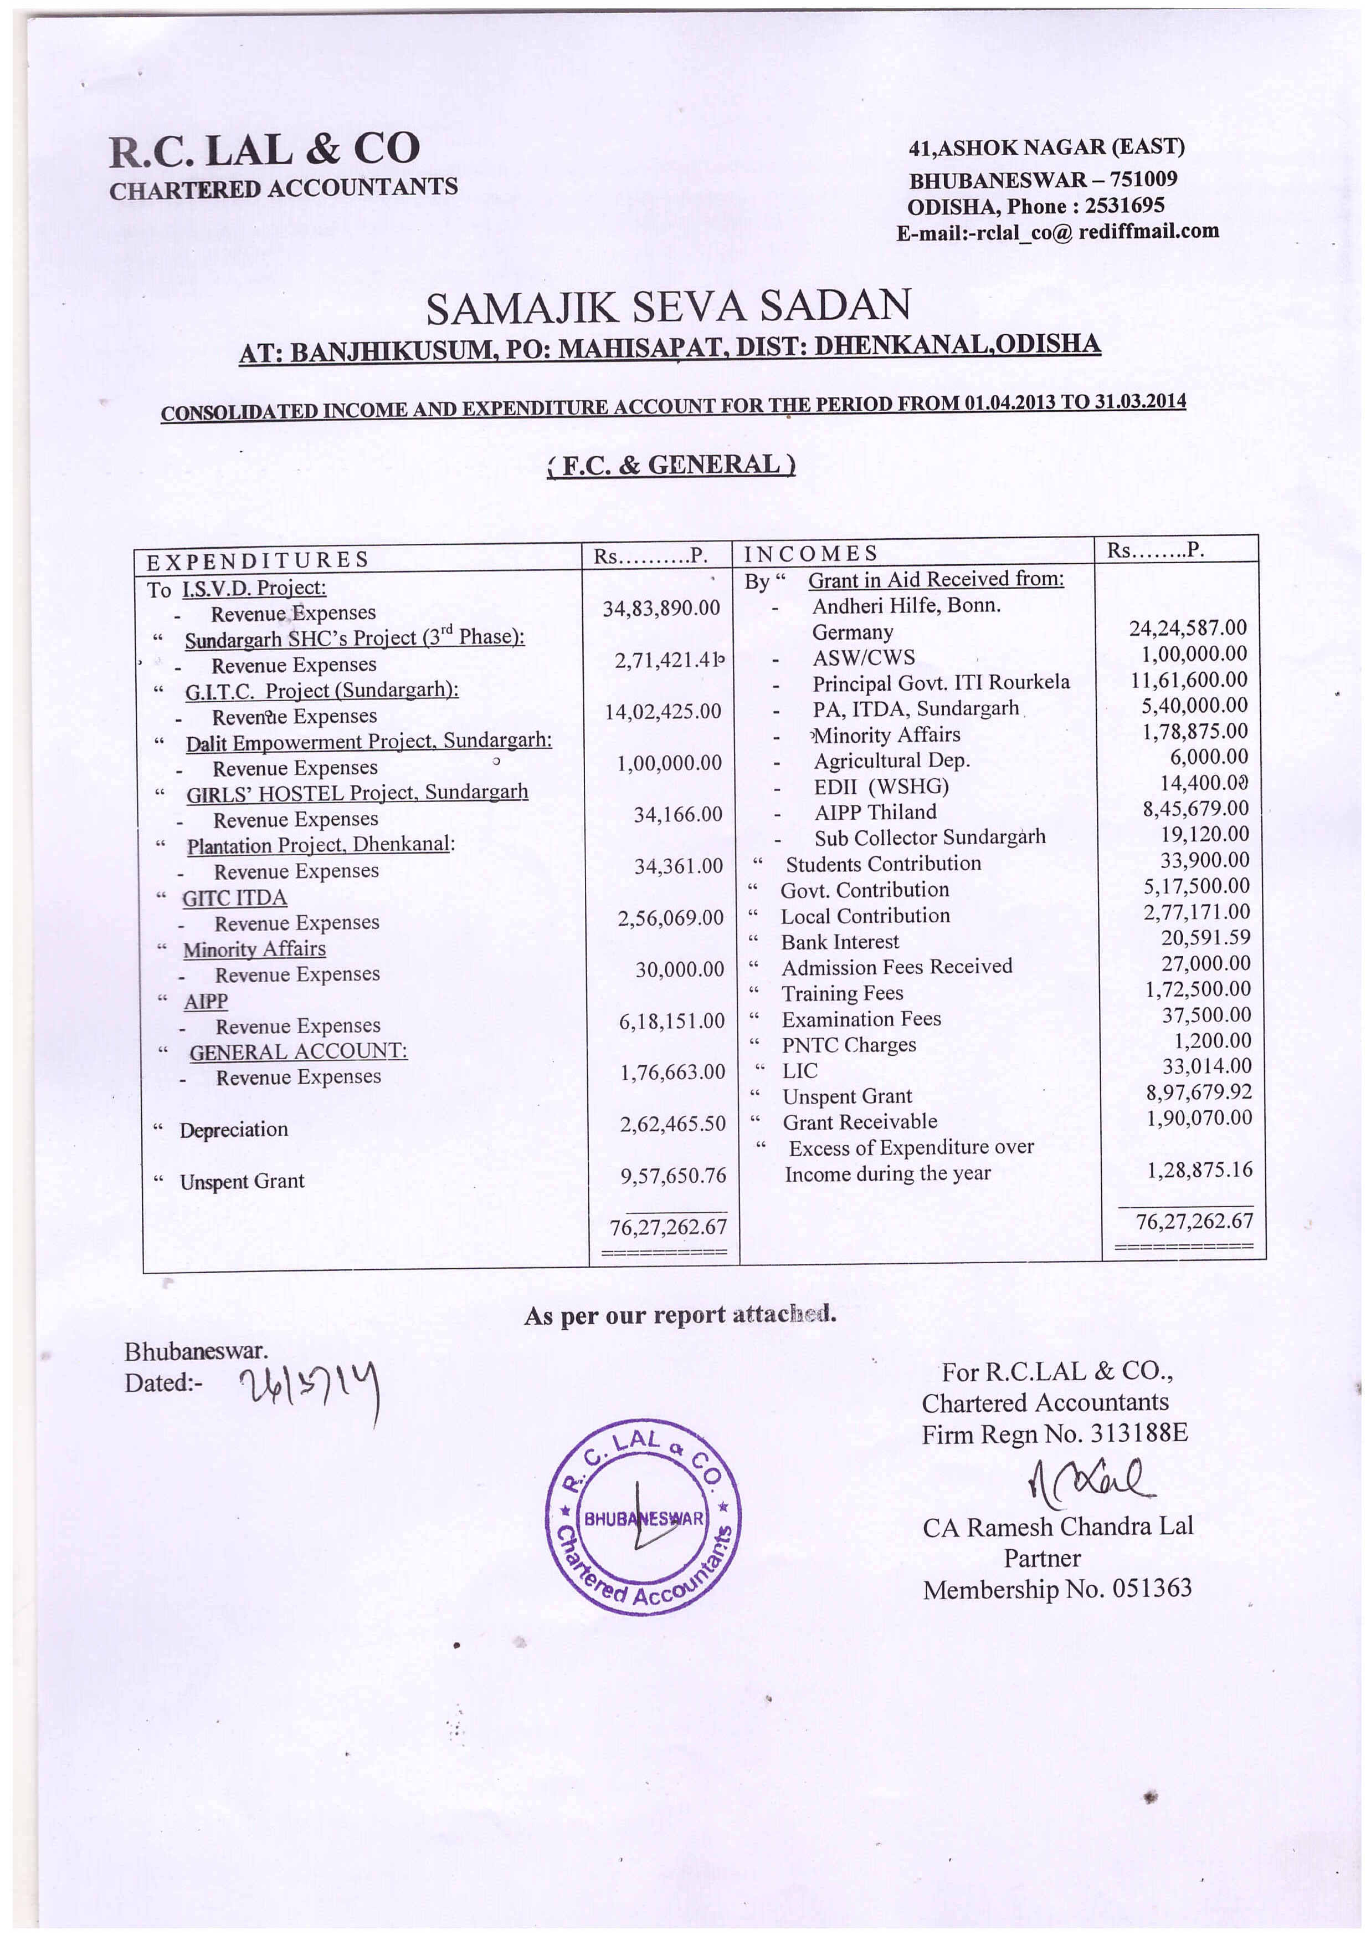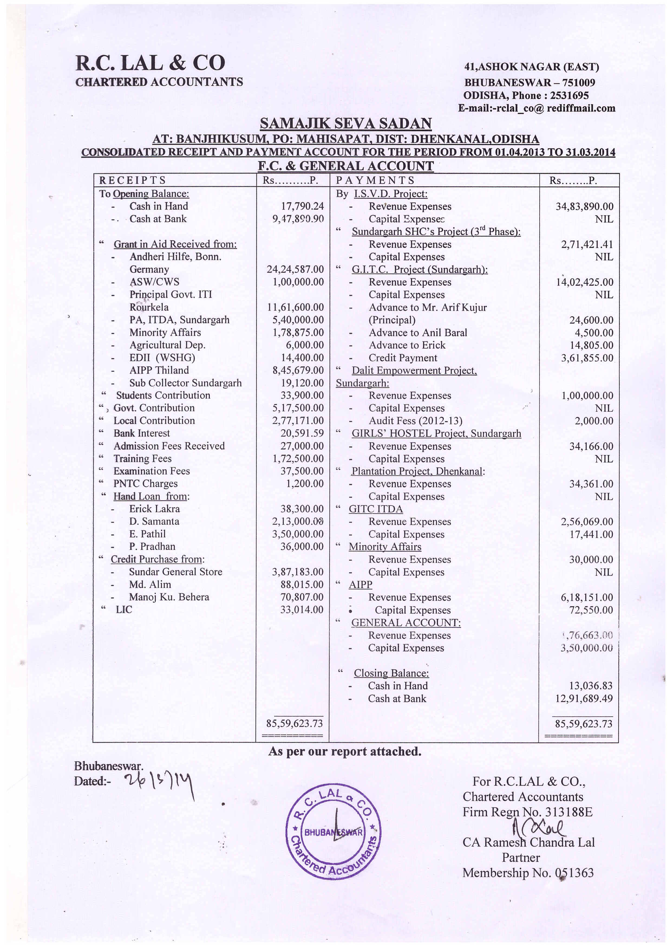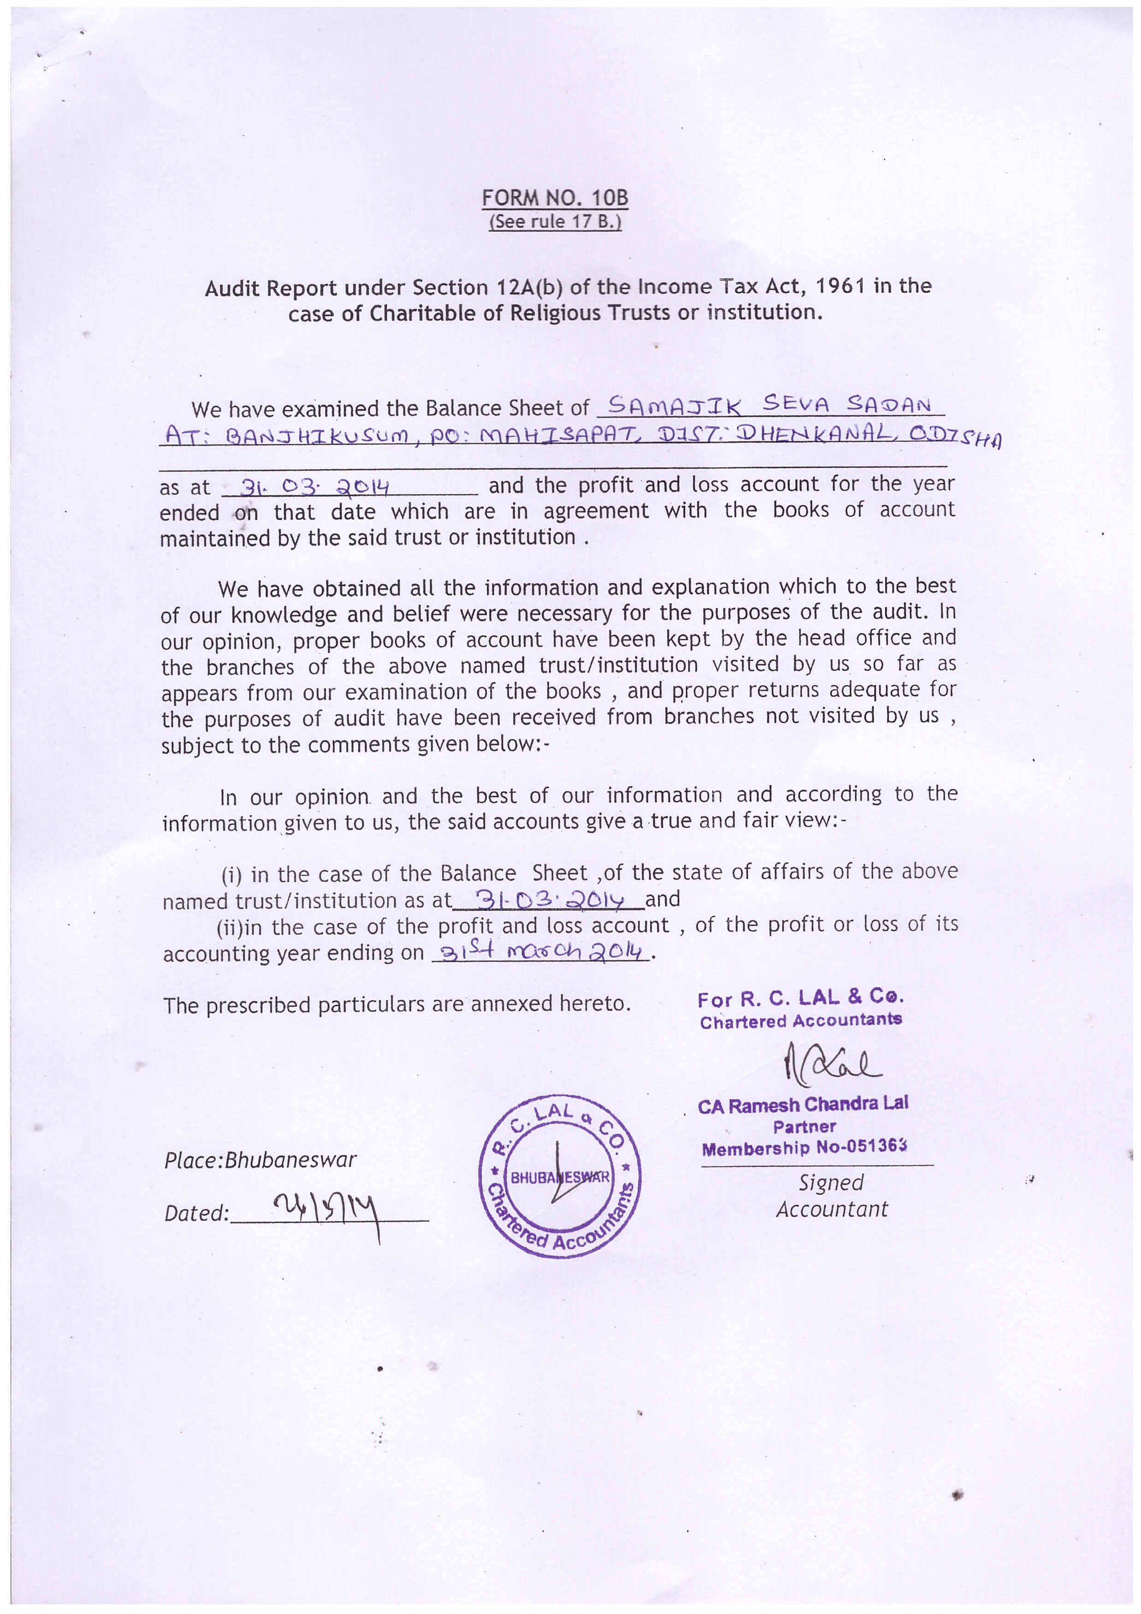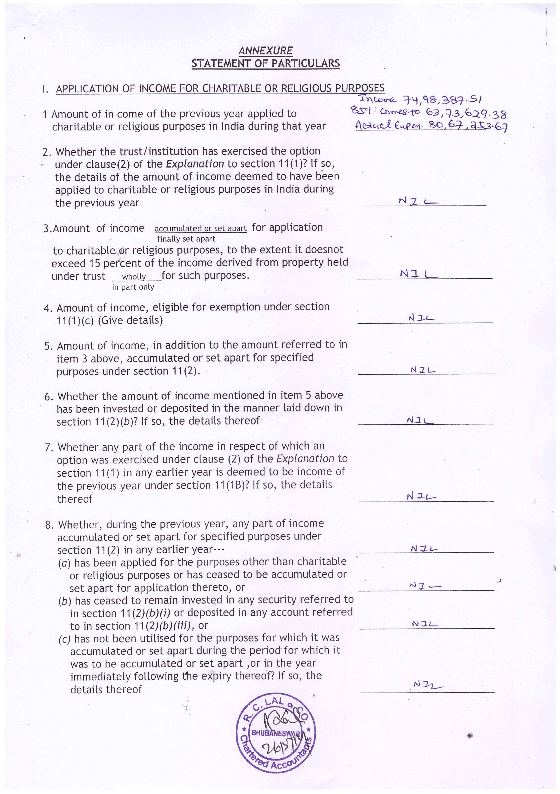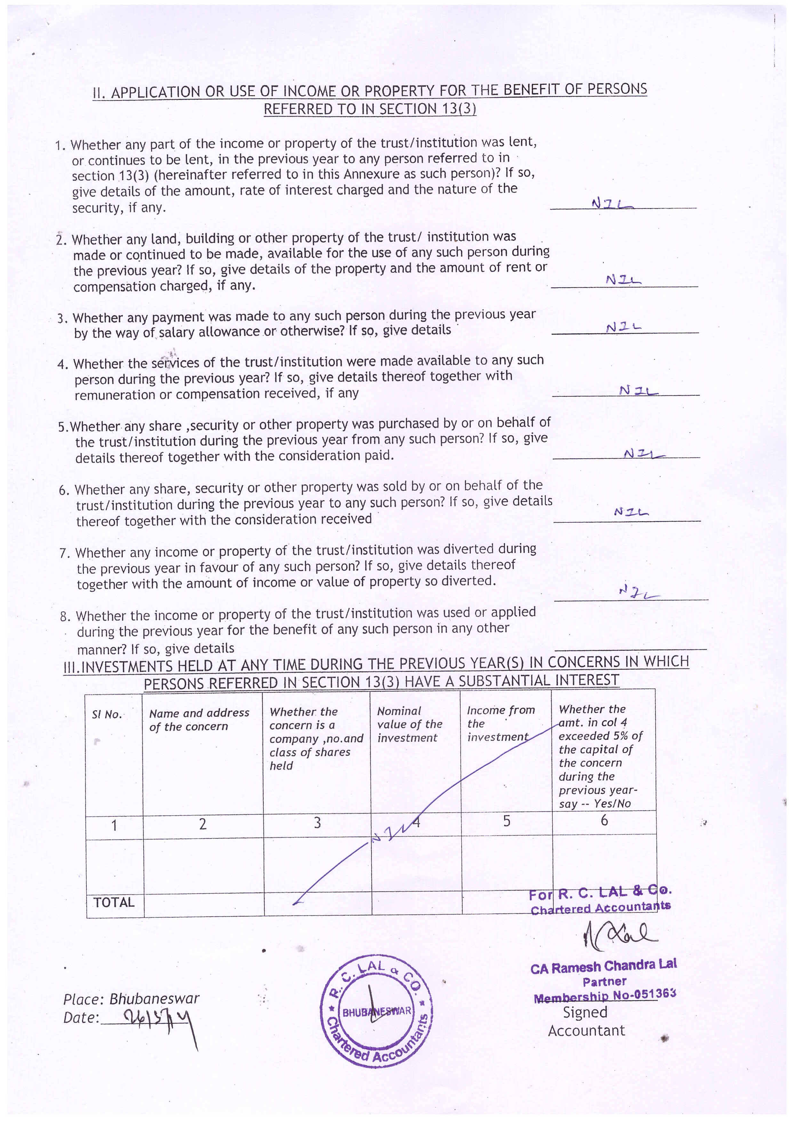

**Conclusion**

We sincerely thank our down trodden people with whom we share our life and participate in their development, spread out in entire District of Dhenkanal, partly in Angul District and 4 Blocks in Sundargarh District. We thank and appreciate the District Administration both at Dhenkanal and Sundargarh for their active cooperation and support as well as involving us in the Developmental activities of these Districts.

We sincerely appreciate and thank the General and Governing Body members, our friends, Well Wishers, Cooperators and Funding Partners who have been a source of strength and support especially in difficult circumstances. I thank and appreciate the volunteers / workers who made their efforts and achievement possible for the people.

Emmanuel Pathil

Director,

THROUGH THE EYES OF THE LENS

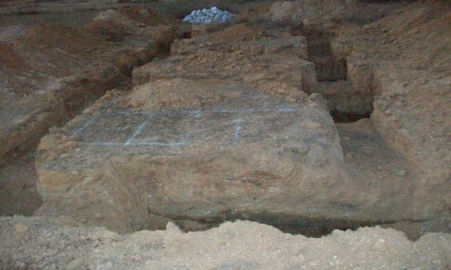

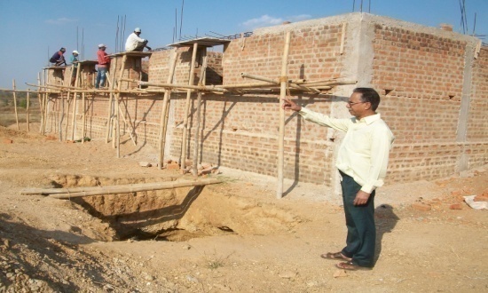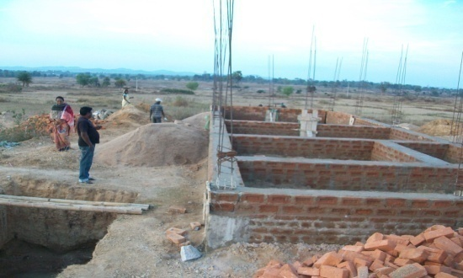

SSS Office Building under construction at Subdega supported by Dr. Dilip Tirki - MP Rajya Sabha, Sundargarh

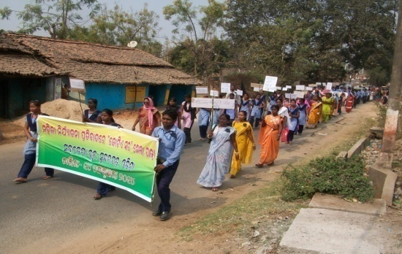

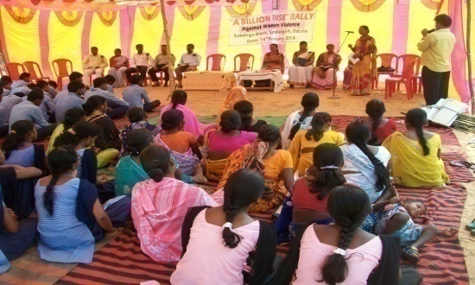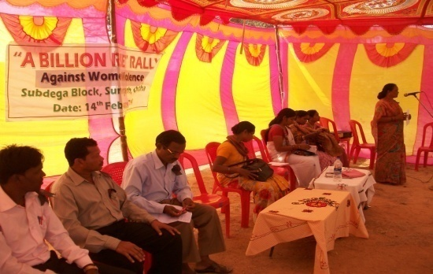

Calibration of Valentines Day & Billion Rise Rally organized in a

Meaningful way on 14th April 2014

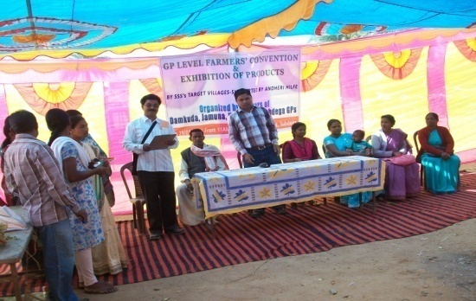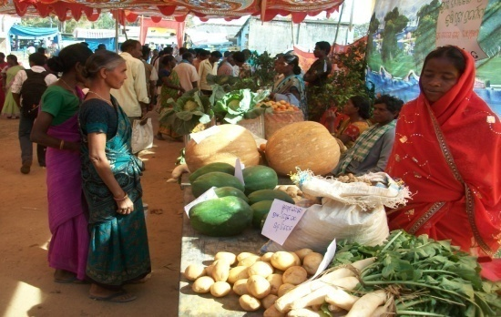

Farmers Convention & Exhibition at Subdega on 24th Jan 2014

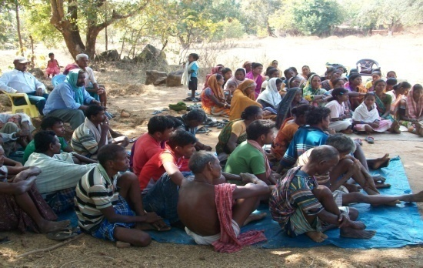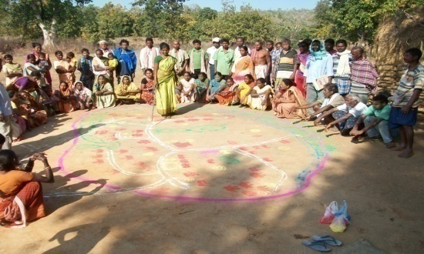

Explaining the Social Map by women of Dungijharia on 9th Jan 2014..

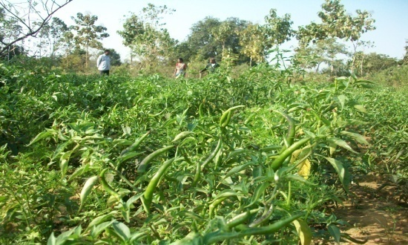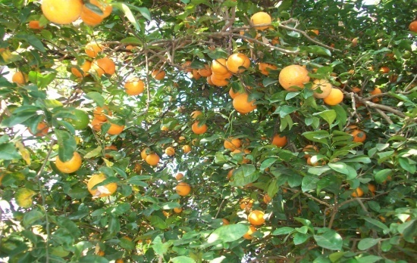

**Orange lemon and chilly farm of Michael-Gungapada-Application of Bio-manure “Moo Aushadha"**

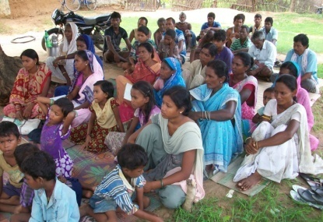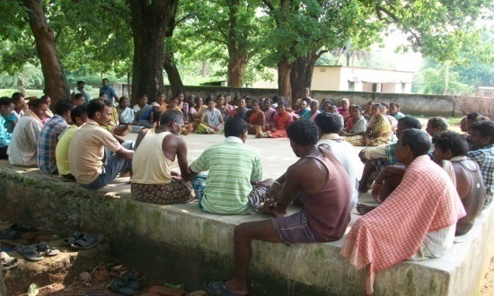

**Village Meetings at Jamuna & Damkuda on Forest Rights Act**

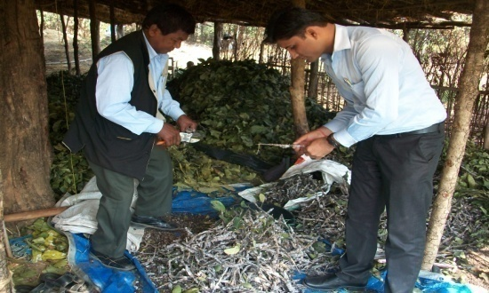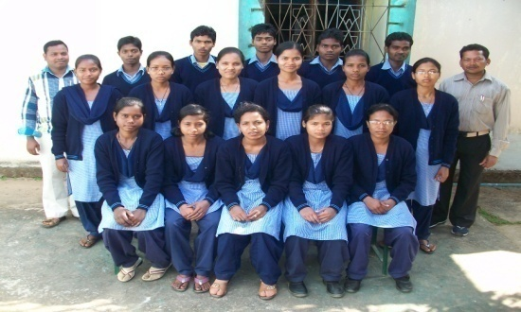

**ITC Electricians- 2013 Lac harvest inspection by Mr. Sony-DRDA**